**LOST CAT- ginger and white male (short haired) on Haultain Street, Hamilton**

* **Last seen on Wednesday 17 February 2021**
* **Please contact 021 1353081 if you know where our pussy cat is**
* **Thank you 😊**

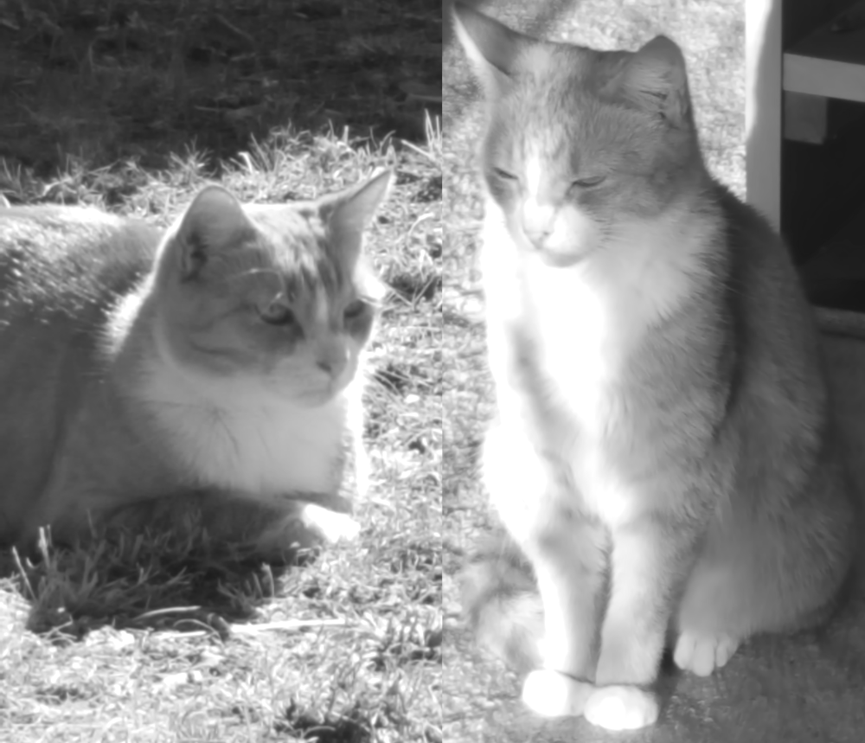

**LOST CAT- ginger and white male (short haired) on Haultain Street, Hamilton**

* **Last seen on Wednesday 17 February 2021**
* **Please contact 021 1353081 if you know where our pussy cat is**
* **Thank you 😊**



**­­­­­­**